**MDF Rose Engine Lathe 2.0**

**with Stepper Motor Drive**



**Instructions for Building the**

**Stepper Controls**

**Version 1.0.2**

**07 December 2020**

This document is intended to help one unfamiliar with the MDF rose engine to build one easily. It is designed to go with the kit you can purchase from [www.ColvinTools.com](http://www.ColvinTools.com).

There are some variations from the ideas documented by Jon Magill at [www.rogueturner.com](http://www.rogueturner.com/). Where this is the case, we have tried to document such changes and provide the reason for the change.

This document is also designed to use a stepper motor for driving the spindle.

If you have any questions, please contact us at [ColvinTools@Gmail.com](mailto:ColvinTools@Gmail.com).

Good luck.

Rich Colvin & Jack Zimmel

Table of Contents

Getting Started 4

Overview of Connections 5

Bill of Materials 7

Controls Box Enclosure 10

Before Assembly 11

Assembly 16

Electrical Plates for Connectors 17

Printed Circuit Board 20

Assembly of the Control Box Electronics 29

Mounting the Covers 29

Mounting Electronics to the MDF Base 30

Switch Settings 40

Stepper Motor Connections 41

Assembly of the Nextion HMI Box 43

System Setup and Program Loading 47

Finishing It Up 52

4Axes.ini Config File Settings 53

Document Version History 57

# Getting Started

As you get started with building this machine, please consider making the machine according to the outlined instructions. There are a boatload of ways you can modify this, and, quite frankly, the MDF rose engine encourages experimentation. But it is best to attempt those modifications after understanding how it works. Some ideas which sound grand may not appear so after understanding how the machine works (we speak from experience).

If you have any questions on the terminology in this document, check out the “Ornamental Turning Book of Knowledge” ([www.OTBoK.info](https://www.otbok.info/)).

This document outlines the approach for wiring this machine using:

1. Rose Engine Controller Spindle and Three Axes V002c printed circuit board
2. DM542T Stepper Motor Drivers
3. Nextion 4.3” HMI Display, model NX4827K043

Standards are outlined in a companion document and are used for the compilation of this document.

Cautions

1. **Do not perform any changes to this system when the system is powered on.** Power down and unplug the system before attempting any work.
2. If your local electrical code requires for any differences from what is documented here, those requirements take precedence over this document.
3. If you feel uncomfortable with anything in these instructions, consider having a licensed electrician perform the work.

**Please also note:** Permission is not granted to manufacture these for sale.

# Overview of Connections

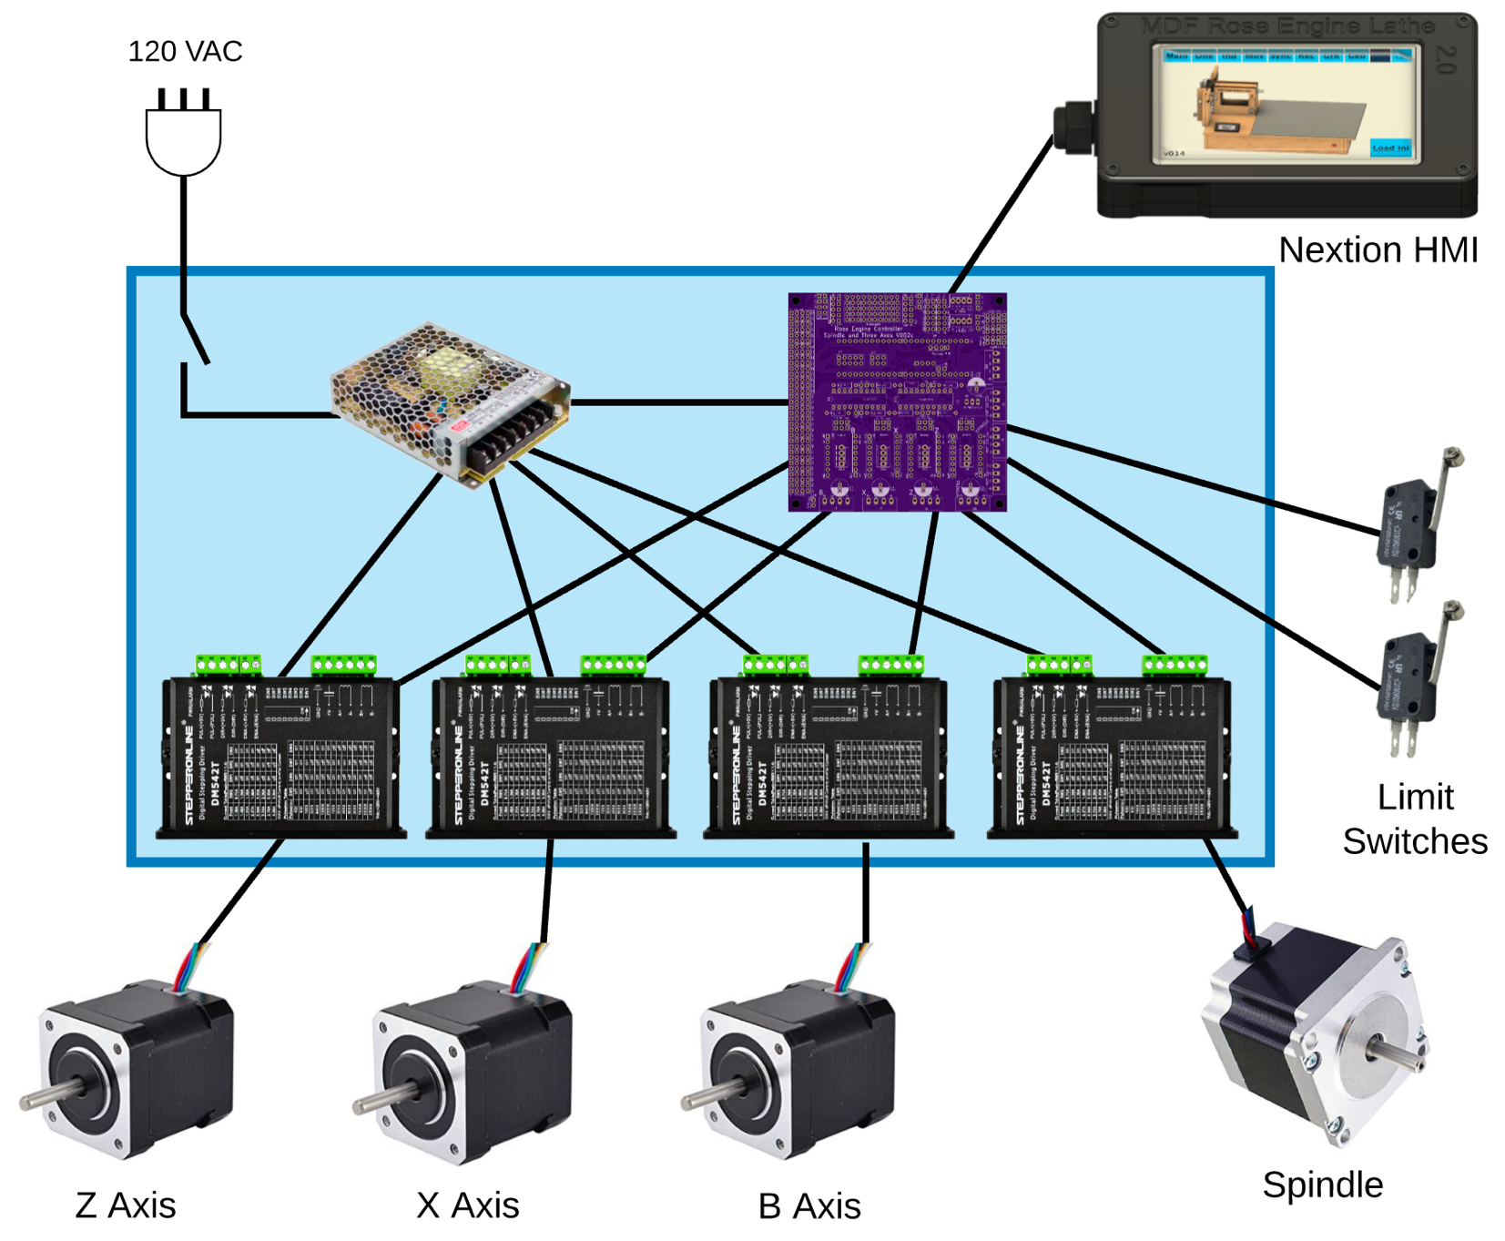The whole system is shown in the picture below.

*Can be added later*

*Can be added later*

The system we supply with the MDF Rose Engine Lathe 2.0 Spindle Drive Option includes:

1. Everything in the Controls Box (the box in blue above)
   1. Power cord and on/off switch
   2. Power supply
   3. Printed Circuit Board with all components attached for 4 drives
   4. Stepper Motor Drivers (4 ea)
   5. Connectors for
      1. Nextion HMI
      2. 4 stepper motors
      3. 6 limit and homing switches
2. Nextion HMI with connecting cable
3. Spindle stepper motor with connecting cable, attaching hardware, drive gears, and drive belt.

The other 3 stepper motors and the two limit switches (and associated attaching cables) are not included but can be added by the user.

Some have chosen to put the stepper motor controls in the lathe’s carcass, under the bed of the lathe. However, placing all the pieces together in a separate box gives these benefits:



**MDF Rose Engine Lathe 2.0**

**(B1 and B1A removed)**

1. This controls box is designed be placed under the bed in the MDF Rose Engine Lathe 2.0 (as shown in the picture to the right {the bed cover is removed}).
2. This approach also allows for the controls box to be used with the original MDF Rose Engine Lathe, just placing the box somewhere near the lathe.
3. This also frees up space under the bed for:
   1. Storage of parts or tools, or
   2. Making a gap-bed lathe.
4. The many connections between the various pieces inside the box are already in place and the user does not have to figure out the correct alignment of connectors when building the MDF Rose Engine Lathe.
5. The connections to the stepper motors and limit switches are documented as standards. This allows for the creation of attachments (such as a curvilinear slide) with a built-in stepper motor and connecting it to the controls box.

The details for how we are building the one you can buy are below. These are documented for our use to ensure consistency, and we are publishing them for anyone who wishes to build their own.

The sequence of activities follows the layout of this document. That was done consciously. Changes to the sequence should be considered strongly before making changes.

# Bill of Materials

### Parts List

Parts required for this section are below. The item numbers used will be highlighted in a circled number like the one to the right.

| Item # | Item | Qty | Source | Source  Part Number | Comments |
| --- | --- | --- | --- | --- | --- |
|  | **Printed Circuit Board Assembly** |  |  |  |  |
| 101 | Printed Circuit Board (PCB) | 1 | OSH Park | 4Rose_002c_Gerbers copy |  |
| 102 | Header Sockets | 2 | Digi-Key | S7022-ND | 24 pins each – mfgr p/n  PPTC241LFBN-RC |
| 103 | 20-pin DIP sockets | 2 | Digi-Key | ED3054-5-ND |  |
| 104 | 10 KΩ resistors | 8 | Digi-Key | CF14JT10K0CT-ND |  |
| 105 | 100 µF electrolytic capacitor | 1 | LCSC | C59414 | Mfgr p/n: KM101M050F115A |
| 106 | 74HCT245 | 2 | Digi-Key | 296-1612-5-ND |  |
| 107 | R-78E5.0-1.0 | 1 | Digi-Key | 945-2201-ND |  |
| 108 | Teensy 3.5 | 1 | PJRC | Teensy 3.5 pins | Be sure to get the one with the pins already soldered into place. |
|  | **Electrical Items** |  |  |  |  |
| 201 | AC/DC Power Supply - LRS-100-24 | 1 | Digi-Key | 1866-3314-ND |  |
| 202 | DM542T Stepper Driver | 4 | StepperOnline | DM542T |  |
| 203 | Nextion 4.3” HMI Enhanced | 1 | ITEAD.cc | NX4827K043 |  |
| 204 | Terminal Block, 10 circuits | 1 | McMaster-Carr | ﻿7618K617 | Could use p/n 7527K51 |
| 205 | Power Switch | 1 |  |  | SPST Toggle |
| 206 | GX-16/ 4 Socket | 4 |  |  | May come as a pair of sockets and plugs  (i.e., including #214) |
| 207 | 3.5mm Audio Jack, Female | 6 |  |  |  |
| 208 | Utility box cover, 2 gang | 2 |  | Hubbell-Raco 804C |  |
| 209 | Utility box cover, 1 gang | 1 | Amazon | Hubbell-Raco 861 |  |
| 210 | Utility box cover, 1 gang | 1 | Amazon | Hubbell-Raco 860 |  |
| 211 | Cable Strain Relief | 1 |  |  |  |
| 212 | Cord Grip | 2 | McMaster-Carr | 69915K47 |  |
| 213 | Stepper Motor | 1 | StepperOnline | 23HS30-30045 | For the spindle drive  NEMA 23 bipolar 1.8°  1.9 Nm, 2.8A, 3.2V  57 x 57 x 76 mm |
| 214 | GX-16/ 4 Plug | 1 | Amazon |  | May come as a pair of sockets and plugs  (i.e., including #206) |
|  | **Cables** |  |  |  |  |
| 301 | Cabling – CAT 5 or higher |  |  |  |  |
| 302 | Cabling – 20 AWG/4, stranded |  |  |  |  |
| 303 | Cabling – 20 or 22 AWG/2, stranded or solid core |  |  |  |  |
| 304 | Cabling – 16 AWG/3, stranded |  |  |  | Can cut off the female end of a grounded extension cord. |
|  | **Screws, etc.** |  |  |  |  |
| 401 | Nylon Spacer (Unthreaded) for #8 screw – ¼” OD, ¼” length | 4 | McMaster-Carr | ﻿94639A293 |  |
| 402 | Brass Heat-Set Inserts for Plastic, #4-40, 0.170” | 4 | McMaster-Carr | 94459A260 |  |
| 403 | Screws, #4-40, ¾” | 4 | McMaster-Carr | 97763A322 |  |
| 404 | M3 Screws, Thread Forming | 4 | McMaster-Carr | 96817A300 |  |
| 405 | Magnets | 4 | Amazon |  | ½” outside diameter with hole in center for attaching to an object via a screw. |
|  | **Spindle Drive Parts** |  |  |  |  |
| 501 | Timing Belt | 1 | MiSUMi | GBN655EV5GT-90 | GT3 5mm pitch  131T / 655mm long  9mm wide |
| 503 | Stepper Motor Pulley | 1 | Stock Drive Products ([www.sdp-si.com](http://www.sdp-si.com)) | A 6A55-012DF0908 | Attached to the stepper motor - 5 mm (GT2) Pitch,12 Teeth, 0.25" Bore, 2 Flanges / With Hub, Aluminum Alloy Timing Pulley for .354 (9mm)" Wide Belt |
| 502 | Spindle Pulley | 1 | Colvin Tools |  | Attached to the spindle |
| 504 | Stepper Motor Attachment Bracket & Parts | 1 | Colvin Tools |  | Includes:   * Bracket with Idler * Mounting bolts, nuts, and spacers to attach to headstock * Mounting screws to attach stepper motor |

Not all screws are shown, only the ones which matter for size or are hard to find.

# A close up of a box Description automatically generatedControls Box Enclosure

The assembled box has

**Side**

1. A top and bottom made from ¾” MDF,
2. Four sides made from ¼” MDF, and
3. 4 corner posts made from quarter-round trim.

**Side**

**Side**

**Bottom**

Removing the top reveals the box shown to the right.

The quarter-rounds are used to give the top and bottom something to set the spacing correctly.

**Side**

The four ¼” thick sides are screwed to the top and bottom.

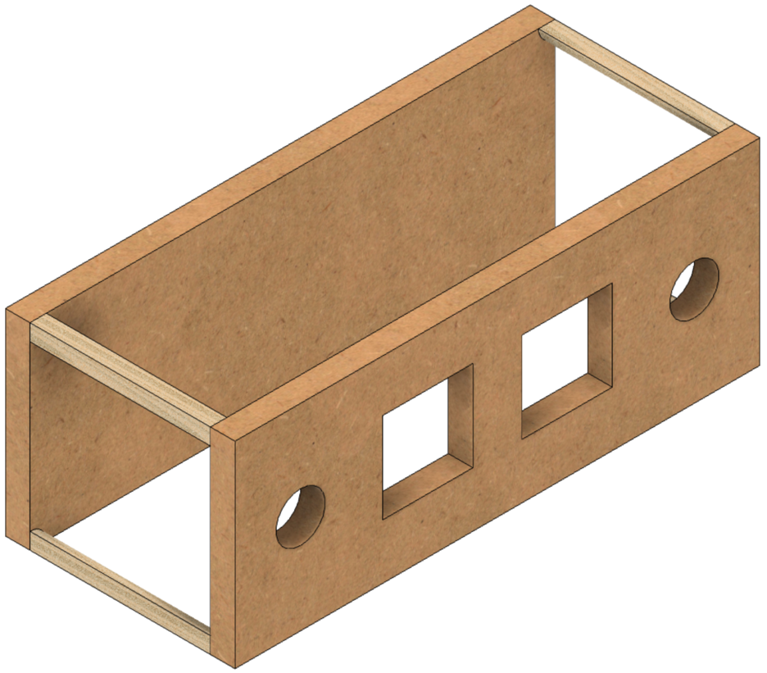Replacing the top, and removing the sides reveals the view to the left.

**Bottom**

**Top**

## Before Assembly

The following instructions should be followed before assembling the controls box

### Bottom

This is made from ¾” MDF.

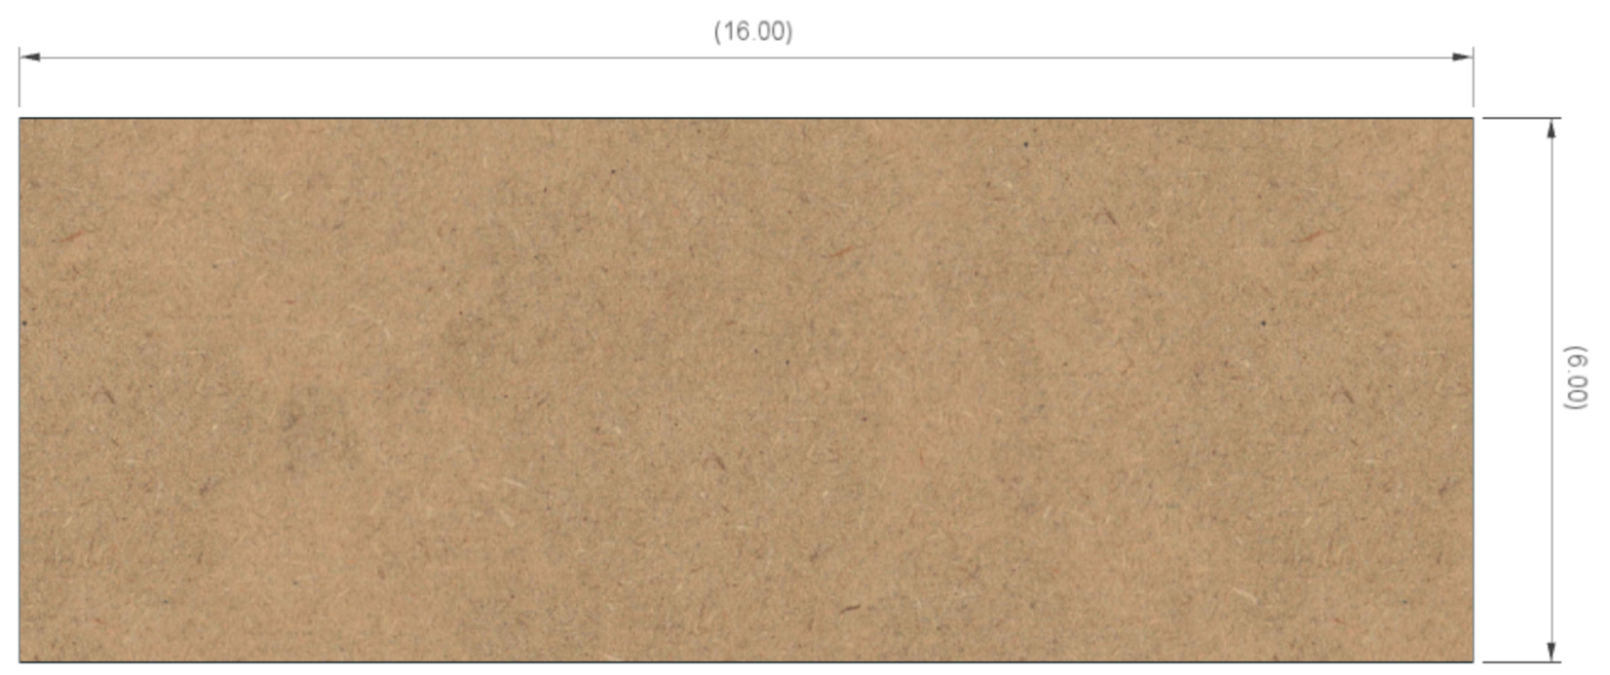

**6”**

**16”**

### Top

1 ½” dia (typ)

This is made from ¾” MDF.

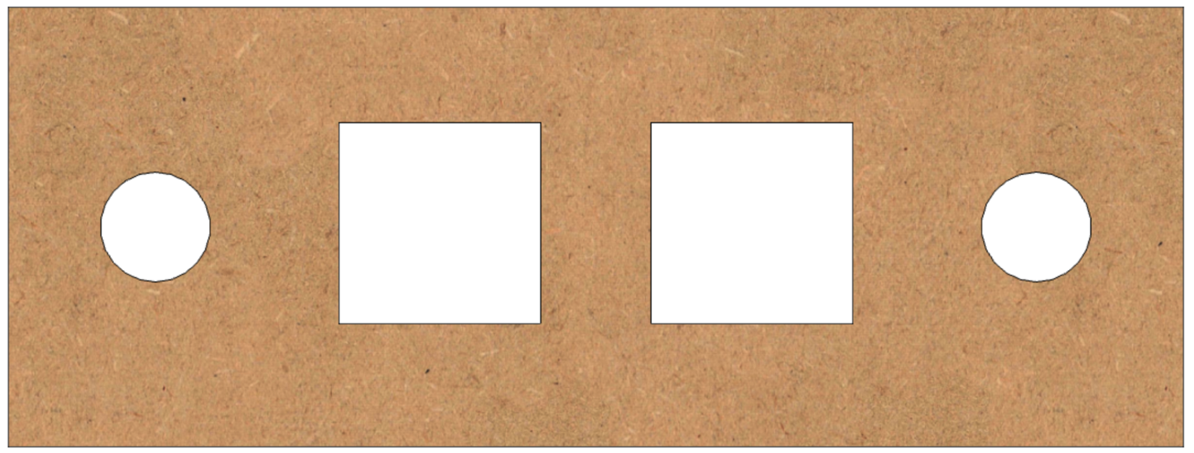

2 ¾”

2 ¾”

6”

3”

2”

2”

2 ¾”

4 ½”

2 ¾”

4 ½”

16”

### A picture containing person, riding, standing, table Description automatically generatedShort Sides (2)

**6 ½”**

There are two of these, and they are made from ¼” MDF.

**6 ½”**

### Long Sides (2)

There are two of these, and they are made from ¼” MDF.

**16”**

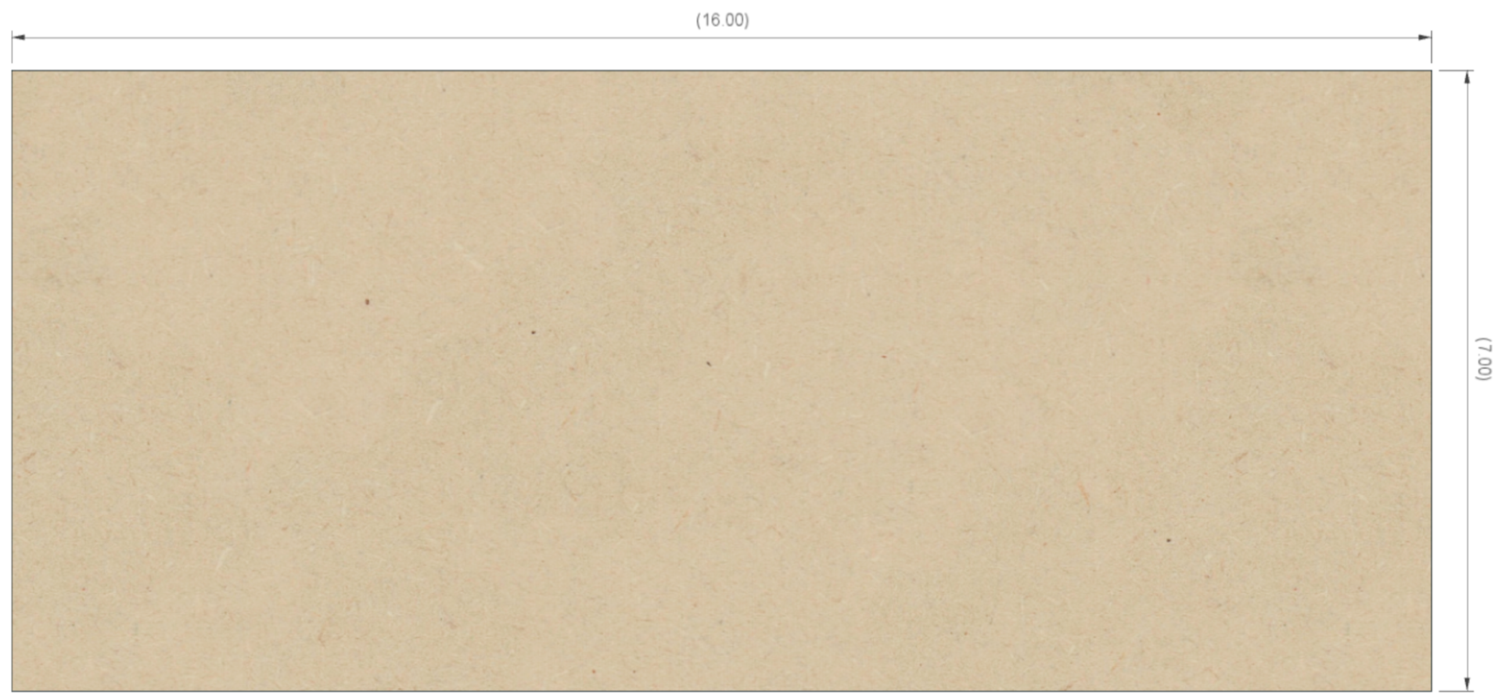

**6 ½”**

### Quarter Rounds (4)

There are four of these, and they are made from any good trim material. These are ½” radius, but that is not terribly critical.

**½”**

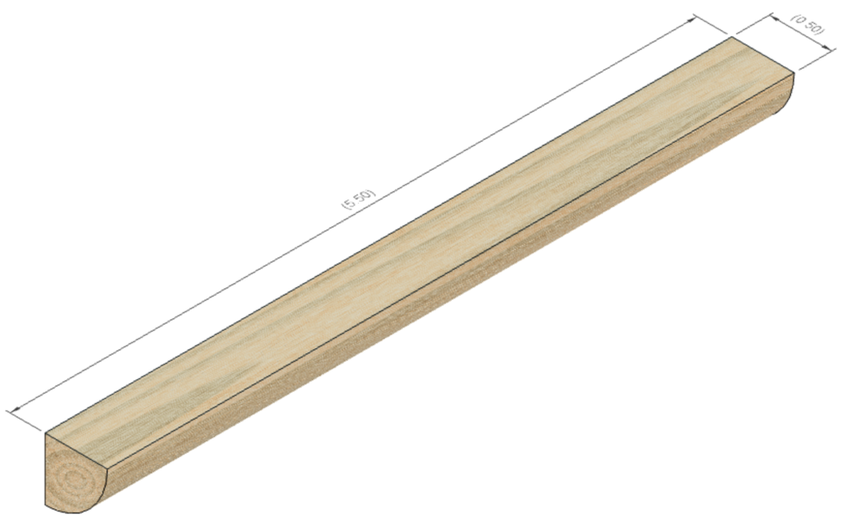

**5”**

## Assembly

Glue the four quarter rounds to the ends of the two long sides. Be certain to:

1. center the quarter round so there is ¾” on each end, and
2. ensure the edges are flush to each other.

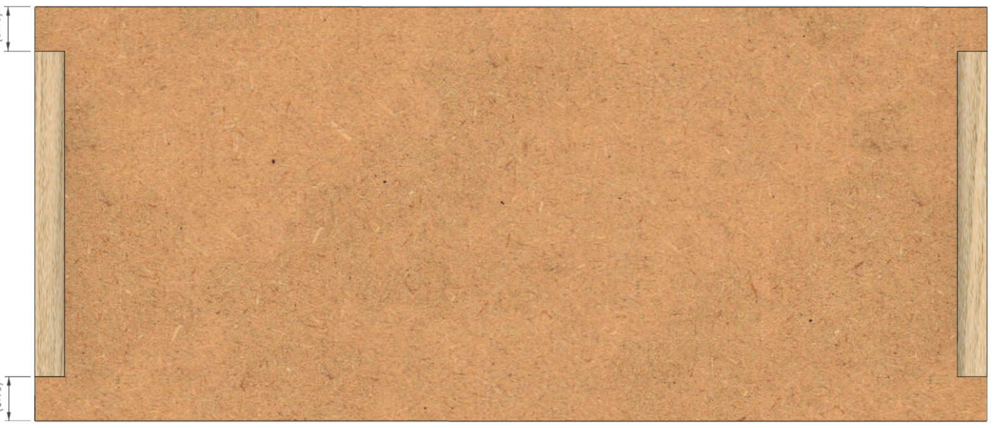

**¾”**

**¾”**

# Electrical Plates for Connectors

### A close up of a speaker Description automatically generatedPower Infeed

Use a 1-gang plate with the hole punched out for the cable strain relief. Secure the power cable in place using the cable strain relief. Wait until the end to tighten it down.

### A computer generated image of a speaker Description automatically generatedPower Switch

****Use a 1-gang plate which is blank. Drill a ½” hole in the center and secure the power switch to it.

### Stepper Motor Plugs



1 ¾”

1 ¾”

**Spindle**

**X Axis**

**Z Axis**

**B Axis**

Use a 2-gang plate which is blank. Drill 4 holes which are each 5/8” diameter.

Label these as:

* Z Axis
* B Axis
* X Axis
* Spindle

### Other Plugs

1”

1”

Use a 2-gang plate which is blank.

Drill 6 holes which are each 15/64” diameter. Label these as:

**Limit & Home Switches**

1”

* Limit & Home Switches
  + 34

**39**

**36**

* + 35

**34**

**37**

**35**

**38**

* + 36

¾”

* + 37
  + 38
  + 39

For the touch screen (the Nextion HMI), there are two options:

1. If you want to use an RJ-45 connector to enable disconnecting the display, then drill 1 hole which is 31/32” diameter. Center it left to right, and 1” from the outer edge. Label this as:

1”

**Touch Screen**

* + Touch Screen

1. You can pass the cable thru this plate using a cable grip as used on the Nextion Display case. If you pursue this option, drill 1 hole that is ½” diameter. Center it left to right and 1” from the outer edge.

# Printed Circuit Board

Attach the parts to the **Rose Engine Controller Spindle and Three Axes V002C** printed circuit board (PCB) using the instructions below.

### Through-Hole Components, part 1

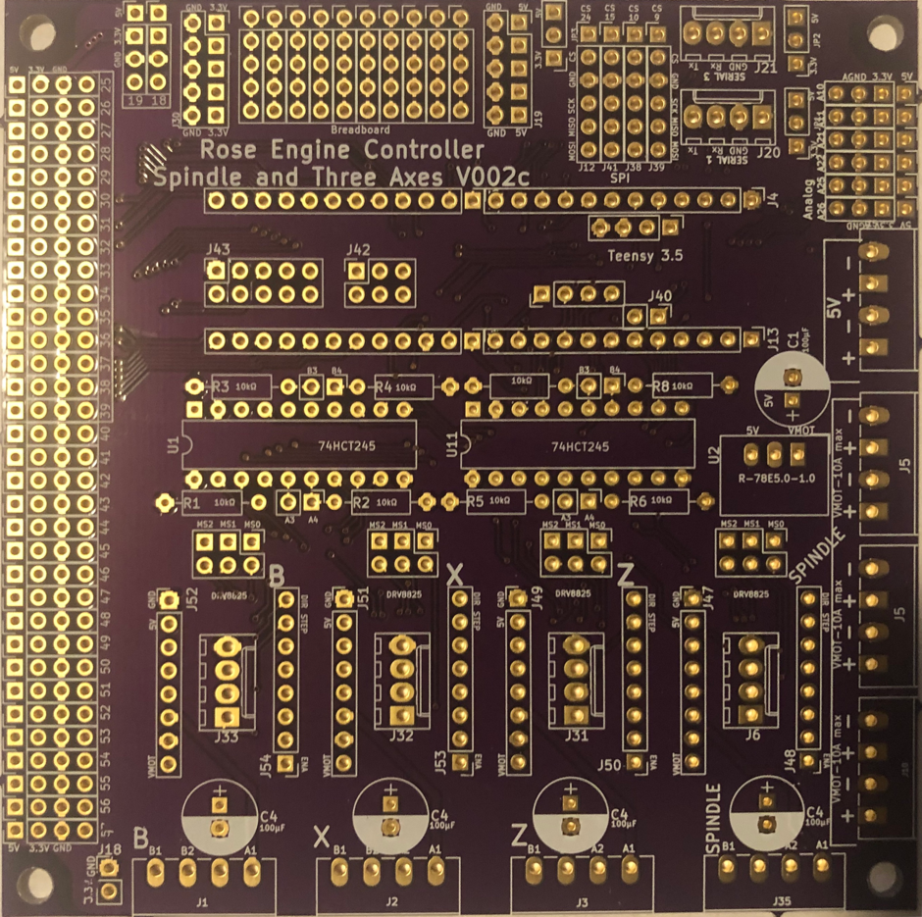Solder in the resistors as noted below.

10 KΩ resistors (8)

### Headers for Integrated Circuits

Solder in the 2 headers for the Teensy, and the 2 DIP sockets for the integrated circuits.

Headers (2) for Teensy 3.5

**NOTE:** The headers must be at 90° to the circuit board. It is necessary to ensure that they remain perpendicular or the Teensy’s pins will not fit into the header pin holes.

20-pin DIP sockets (2) for 74HCT245s

**NOTE:** The sockets have direction indicators on them. Ensure they match the direction indicators on the board (the little curved part of the marking on the board). This is to ensure the item is inserted correctly.

### Through-Hole Components, part 2

Solder in the components noted below.

**NOTE:** Be sure the capacitor is set correctly. The – side goes in the area shaded white.

**NOTE:** The DC converter should fit over the box printed for it on the board.

100 µF Capacitor

R-78E5.0-1.0 DC DC Converter

### Cabling, general

This section is about connecting the PCB to the other components via appropriate cabling. This can be done two ways:

1. Best practice recommendation is to put jacks onto the board and connect the wires via the opposite jack end. If you go that route, do consider making the design “dummy proof”. By that I mean,
   1. Use different types of connectors for the Nextion HMI display than for the stepper motors. Both use a 4-wire connection, and you want to prevent the connector being attached to the wrong place. The two typical options are:
      1. Use a male connector on the PCB for one (e.g., the Nextion display), and female connectors for the other (e.g., the stepper motors), or
      2. Use a 5-wire connector for one, just ignoring the 5th wire option.
   2. Use keyed connectors which prevent the user plugging the cable into the board backwards.
2. The option that can also be taken is to solder the wires directly to the board.
   1. That works well unless the wires are subject to movement which can cause them to break from the PCB. If you plan to disassemble and re-assemble your system often, consider not using this option.
   2. However, this option helps in that the connectors won’t jar loose.

**NOTES:**

1. If you connect the wires to the PCB directly, I recommend soldering the stranded wires into place first. They are the most difficult.
2. Before soldering the stranded wires, be sure to tin the wires first.

### Cabling, part 1

Solder in the cables as noted below.



**Cabling for DM542T Drivers (4)**

(same for B, X, & Z)

|  |  |
| --- | --- |
| ⭘ GND | White |
| ⭘ DIR | Red |
| ⭘ STEP/PUL | Black |
| 🞎 ENA | Yellow |
| Enable is square & closest to the J6 / J31 / J32 / J33 label. The rest are in the order shown in the table. | |
| 20 AWG / 4 – Stranded | |
| Cables 8-10” long | |

### Cabling, part 2

Solder in the cables as noted below.



**Cabling for 24 VDC Power Feed**

|  |  |
| --- | --- |
| ⭘ -24V | White |
| 🞎 +24V | Red |
| 22 AWG / 2 | |
| Cable 15” long | |

### Cabling, part 3

**Cabling for Nextion Display**

|  |  |
| --- | --- |
| ⭘ Tx | White/Green |
| ⭘ Rx | White/Orange |
| ⭘ GND | Orange |
| 🞎 +5V | Green |
| +5V is closest to the J20 label. The rest are in the order shown in the table. | |
| Cat-5 or higher | |
| * If connecting thru the panel to the Nextion HMI display (using a cable grip on the panel), 7 feet long. (recommended) * If connecting to a panel mount connector, 8” long. | |

Solder in the cables as noted below.



**NOTE:**

* Tx on the PCB is connected to Rx on the touch screen.
* Rx on the PCB is connected to Tx on the touch screen

### Cabling, part 4

Solder in the cables as noted below.



**NOTE:** If the jumper is not connected, there will be no power going to the Nextion HMI.

**Jumper for Nextion Power Option**

|  |  |
| --- | --- |
| ⭘ JP1 | Red or Black |
| 🞎 5V |
| 22 AWG / 2 | |
| Cable is 1 ½” long | |

### Cabling, part 2

Solder in the cables as noted below.

**Cabling for Limit Switches (2)**

|  |  |
| --- | --- |
| ⭘ Pin # | Red |
| ⭘ GND | White or Black |
| ⭘ 3.3V | (unused) |
| 🞎 5V | (unused) |
| Pins 34 to 39 | |
| 22 AWG / 2 - Stranded | |
| 8” long | |

**NOTE:** it may be easier to attach the jacks to the wires before soldering them into place on the board. If you want to do that, follow the steps on pg. 38 before talking this step.

# Assembly of the Control Box Electronics

## Mounting the Covers

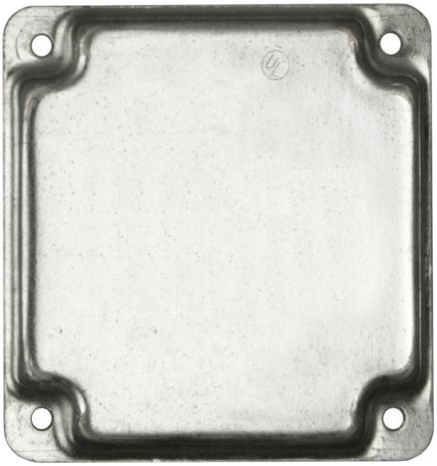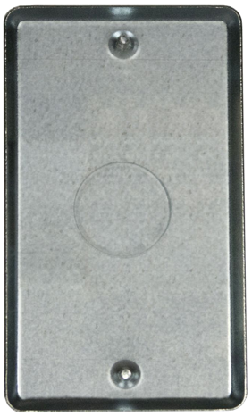

**Touch Screen**

**Limit & Home Switches**

**36**

**34**

**35**

**39**

**37**

**38**

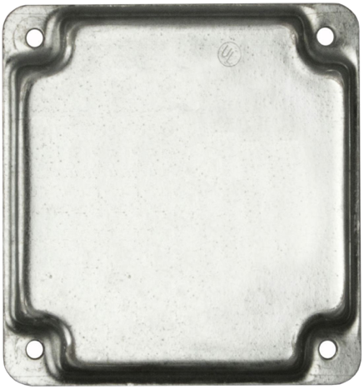

**Spindle**

**X Axis**

**Z Axis**

**B Axis**

## Mounting Electronics to the MDF Base

Mount the electronics to the base piece of the MDF.

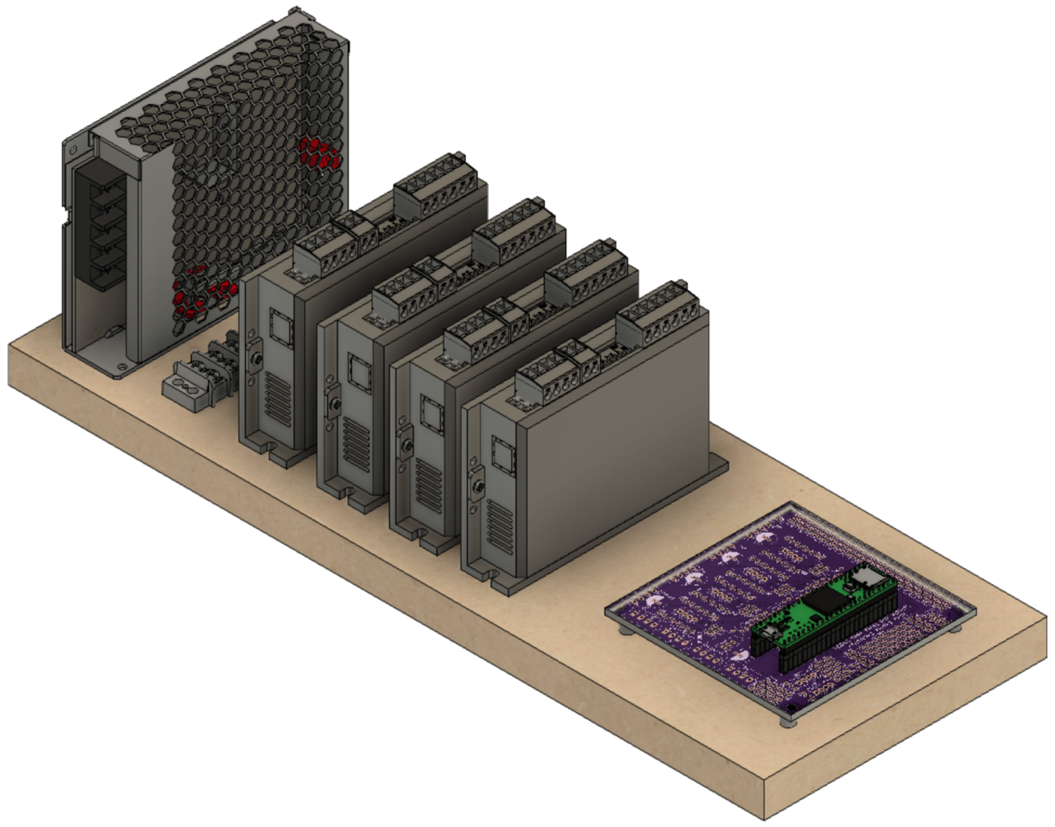

**DM542T – B Axis**

**LRS-100-24**

**PCB**

(sitting atop spacers)

**DM542T – Spindle**

**DM542T – X Axis**

**DM542T – Z Axis**

**Terminal Block**

### A circuit board Description automatically generatedMounting the PCB to the MDF Board

The Teensy microcontroller is installed onto the PCB as shown in the picture to the right.

The two 74HCT245 integrated circuits are installed as shown in the picture to the right. Note that the indicating mark should be on the left side.

The entire board is secured to the MDF with the ¼” spacers under the 4 corners to place the board so that there is a ¼” gap below.

### Wiring – Power Supply (LRS-100-24)

|  |  |
| --- | --- |
| Conductor Type | Stranded copper |
| Conductor Size | 16 AWG (min) |
| Cable Size | 3 conductors / cable |

#### Power Infeed

The power infeed is connected as:



|  |  |
| --- | --- |
| Wire Color | Power Switch |
| Black Incoming Power | Terminal 1 |
| Black Outgoing Power | Terminal 2 |

|  |  |
| --- | --- |
| Wire Color | LRS-100-24 |
| Black from Power Switch Terminal 2 | L |
| White | N |
| Green | GND (A picture containing drawing  Description automatically generated) |



Black

White

Black

Green

#### A picture containing honeycomb, food, oven Description automatically generatedPower Outfeed

terminal block is used to make the installation and maintenance of the system’s components easer. Using a terminal block allows connections to be added, changed, or removed without the risk of any other connections loosening.

|  |  |
| --- | --- |
| Conductor Type | Stranded or solid copper |
| Conductor Size | 20 or 22 AWG |
| Cable Size | 2 conductors / cable |

One of the power supply’s **+V** outfeeds, and one of the **-V** outfeeds is connected up to the terminal block where the power will be distributed.

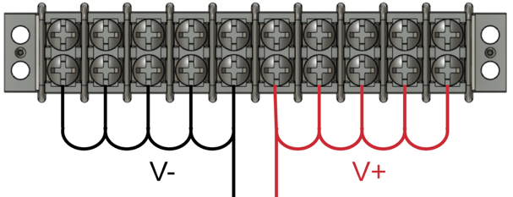

1. **-V** is connected to the other side of the terminal block using a white or black wire. That same colour wire is then used to cascade the -V side of the power to the next 4 terminals.
2. **+V** is connected to one side of the terminal block using a red wire, and then that same colour wire is used to then cascade the +V side of the power to the next 4 terminals.

### Power Wiring – Printed Circuit Board (PCB)

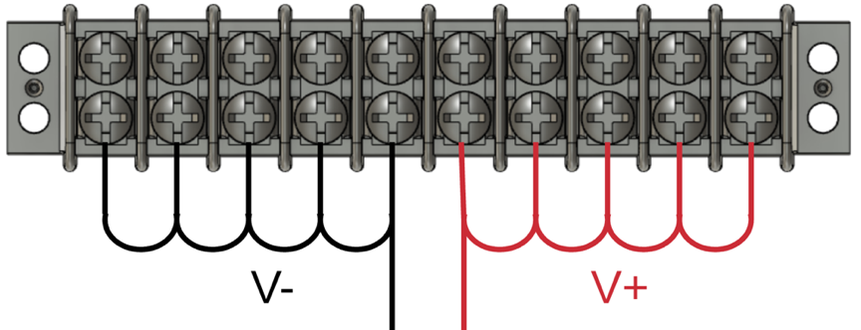The PCB is connected to the terminal block for power. The cable from the PCB is already in place from earlier instructions in this document.

|  |  |  |
| --- | --- | --- |
| Terminal Block | Wire Color | PCB |
| +V terminal | Red | ⭘ +24V |
| -V terminal | White | ⭘ -24V |

### Power Wiring – DM542T Stepper Motor Drivers (4)

Each of the 4 DM542T stepper motor drivers is connected to the terminal block for power.

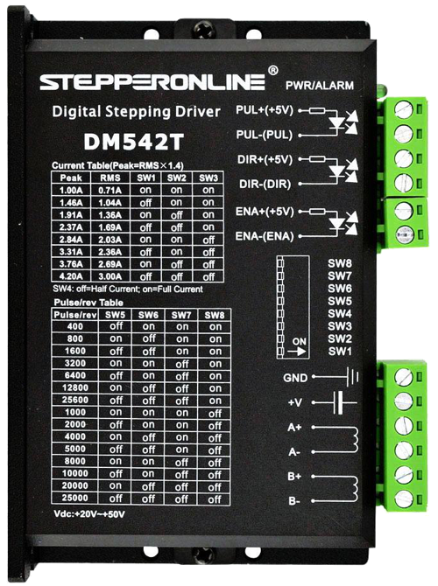

|  |  |  |
| --- | --- | --- |
| Terminal Block | Wire Color | DM542T |
| +V terminal | Red | +V |
| -V terminal | White |  |

|  |  |
| --- | --- |
| Conductor Type | Stranded or solid copper |
| Conductor Size | 20 or 22 AWG |
| Cable Size | 2 conductors / cable |

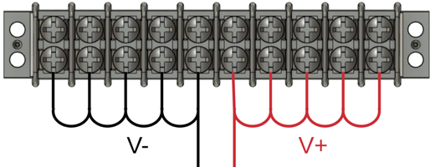

### Signal Wiring – PCB to Stepper Motor Drivers (4)

Each of the 4 DM542T stepper motor drivers is connected to the PCB via 20 AWG/4 stranded wire. The cable from the PCB is already in place from earlier instructions in this document. The cabling for the Spindle’s driver is shown; the other 3 are similar.



|  |  |  |
| --- | --- | --- |
| DM542T | Wire Color | PCB |
| Direction + | Red | ⭘ DIR |
| Direction - | White (GND) * | ⭘ GND |
| Enable + | Yellow | 🞎 ENA |
| Enable - | White (GND) * | ⭘ GND |
| Pulse + | Black | ⭘ STEP/PUL |
| Pulse - | White (GND) * | ⭘ GND |

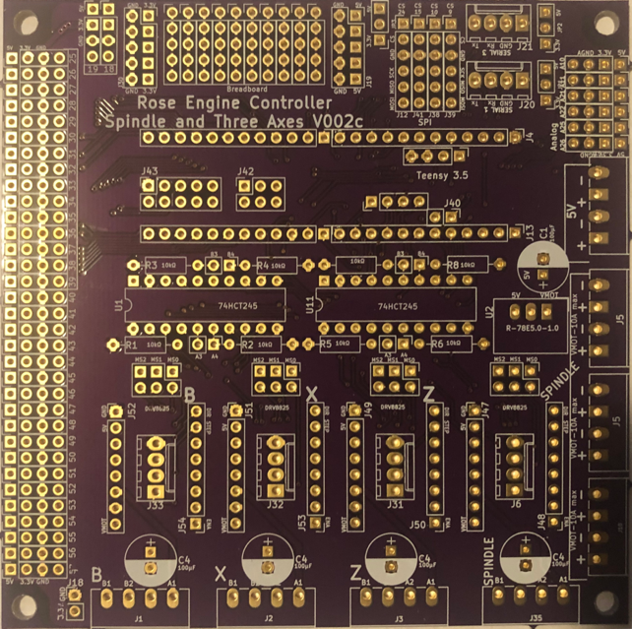* GND wires tied / bonded together.

(only one driver is shown)

### Signal Wiring – PCB to RJ-45 Jack for Nextion Display

The Nextion HMI is connected to the PCB via an RJ-45 connector. The cable from the PCB is already in place from earlier instructions in this document.



Rx

+5V

GND

Tx

|  |  |  |
| --- | --- | --- |
| PCB | Wire Color | RJ-45 Pin |
| ⭘ Rx | White/Green | 1 |
| 🞎 +5V | Green | 2 |
| ⭘ Tx | White/Orange | 3 |
|  | Blue | 4 |
|  | White/Blue | 5 |
| ⭘ GND | Orange | 6 |
|  | White/Brown | 7 |
|  | Brown | 8 |

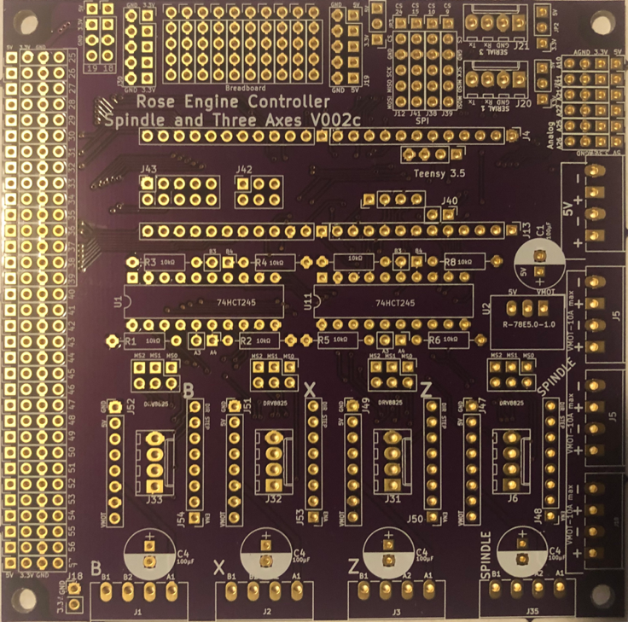

**NOTE:**

* Tx on the PCB is connected to Rx on the touch screen.
* Rx on the PCB is connected to Tx on the touch screen

### Signal Wiring – PCB to 3.5mm Audio Jack for Limit & Home Switches

The limit switches are connected to the PCB via a 3.5mm (1/8”) audio female jack. Pins 34 - 39 on the Teensy are used (one for each limit switch). The cable from the PCB is already in place from earlier instructions in this document.

|  |  |  |
| --- | --- | --- |
| PCB | Wire Color | Audio Jack |
| ⭘ pin # | Red | Tip / pin 2 |
| ⭘ GND | White or Black | Sleeve / pin 1 |

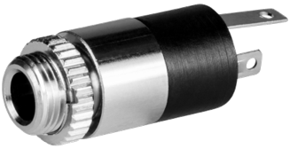

(only one jack is shown)

1 - Sleeve

2 - Tip

**NOTES:**

1. Most audio jacks that are available are stereo with 3 connectors. Only 2 are needed, so the 3rd one will go unused. Typically, pins 1 and 2 should be used, and 3 should be left unconnected. But check based on the jack you are using.
2. Experience has shown that it is a good practice to ensure a mono plug will work correctly for the way you have soldered the connections.

### Signal Wiring –Stepper Motor Drivers to GX-16/4 Jacks (4)

Each of the 4 stepper motors is connected to the stepper motor drivers via GX-16/4 Jacks.

|  |  |  |
| --- | --- | --- |
| DM542T | Wire Color | GX-16/4 Pin |
| A+ | Black | 1 |
| A- | Yellow | 2 |
| B+ | Red | 3 |
| B- | White | 4 |

|  |  |
| --- | --- |
| Conductor Type | Stranded copper |
| Conductor Size | 20 AWG |
| Cable Size | 4 conductors / cable |
| Cable Length | 6 to 8” |

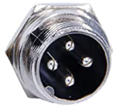

2

3

4

1

## Switch Settings

Set the switches on the DM542Ts as:



|  |  |  |  |
| --- | --- | --- | --- |
| Purpose | Set to | Switch | Setting |
| Current | 2.8A Peak  2.03A RMS | 1 | ON |
| 2 | ON |
| 3 | OFF |
| Half Current | 4 | OFF |
| Pulses / Rev | 6400 | 5 | OFF |
| 6 | ON |
| 7 | OFF |
| 8 | ON |

The current could be set higher with this driver; however, the selected NEMA 23 stepper motor does not need that, so it is set thusly.

**NOTE:** switch settings in the picture are not correct – this is a stock photo from the Internet. Use the settings in the table above.

# Stepper Motor Connections

Each of the stepper motors is connected to the stepper motor drivers via GX-16/4 plugs. For the spindle drive, a 3 foot cord is recommended. Stepper motor wire colors shown are for the StepperOnline motors. Check that the one you use matches for the connection needed.



|  |  |  |  |
| --- | --- | --- | --- |
| Stepper Motor | Stepper Motor Wire | Cable Wire Color | GX-16/4 Pin |
| A+ | Black | Black | 1 |
| A- | Green | Yellow | 2 |
| B+ | Red | Red | 3 |
| B- | Blue | White | 4 |

|  |  |
| --- | --- |
| Conductor Type | Stranded copper |
| Conductor Size | 20 AWG |
| Cable Size | 4 conductors / cable |

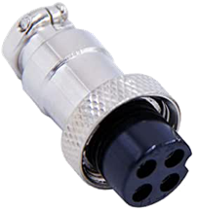

1

2

3

4

Put a ¾” long piece of shrink file onto each one of the stepper motor wires before connecting it to the cable 5 wires.



Connect the cable wires to the stepper motor wires using a lineman’s splice (AKA, the Western Union splice, and shown to the right), and then solder the two together.

Heat the shrink file tubing around each of the joints to insulate it from the other things it could touch.

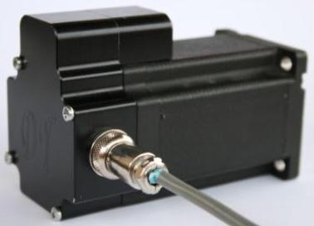Alternatively, you can add a back cover to the stepper motor. This gives a secure way to attach the signal wires to the motor. These are available from a number of sources, and they can even be 3D printed. Look for one online using the term “stepper motor back cover”.

In this case, connect the stepper motor to the GX-16/4 jack as:

|  |  |  |
| --- | --- | --- |
| Stepper Motor | Stepper Motor Wire | GX-16/4 Pin |
| A+ | Black | 1 |
| A- | Green | 2 |
| B+ | Red | 3 |
| B- | Blue | 4 |

# A screenshot of a computer screen Description automatically generatedAssembly of the Nextion HMI Box

### Attach Nextion Display to the Bezel

One hole is printed into the back side of the bezel for attaching the Nextion HMI (circled in red to the right). That one needs to be enlarged using a #39 drill to a depth of 1/8”.

Attach one corner of the Nextion HMI using an M3 Thread Forming Screw, then center the HMI. Drill the other 3 corners, and then attach the display using the remaining M3 Thread Forming Screws.

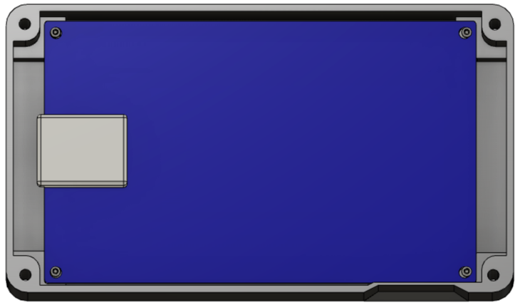

Note that the Nextion is inserted upside down. This is because the microSD card slot is then pointed down. And the microSD card slot is accessible so that upgrades can be done without having to disassemble the whole system. (The slot for inserting the microSD card is in the base, not the bezel.)

### A close up of a computer Description automatically generatedAttach Parts to the Base

Attach the 4 magnets to the base’s bottom. There are 4 insets in the base for these.

If the screws protrude into the base, take some efforts to grind or file those sharp points down.

### A picture containing sitting, electronic, monitor, oven Description automatically generatedInsert the Heat-Set Inserts

Using a heat gun, insert each of the heat-set inserts into the corners of the base.

### Add Wire Cord Grip

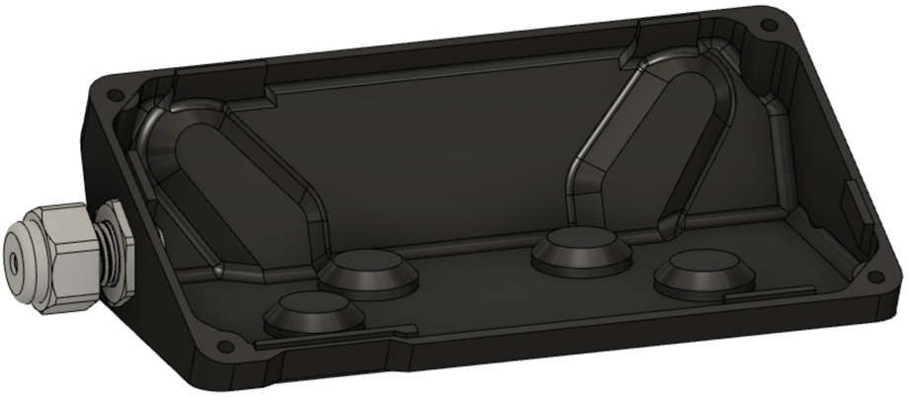The cord grip is used to ensure the signal wire does not pull against the Nextion display.

Depending on the printing, you may need to drill the whole with a ½” bit to ease the installation.

### Signal Wiring – PCB to RJ-45 Jack for Nextion Display

|  |  |  |  |  |
| --- | --- | --- | --- | --- |
| Nextion Connection | Nextion Wire Color |  | CAT 5  Wire Color | RJ-45 Pin |
| RX | Yellow |  | White/Green | 1 |
| +5V | Red |  | Green | 2 |
| TX | Blue |  | White/Orange | 3 |
|  |  |  | Blue | 4 |
|  |  |  | White/Blue | 5 |
| GND | Black |  | Orange | 6 |
|  |  |  | White/Brown | 7 |
|  |  |  | Brown | 8 |

The Nextion HMI is connected to the connection box via an RJ-45 connector. Using piece of CAT 5 (or greater) wire, 4 feet long, make the connections to the HMI’s connector (supplied by the vendor) as shown to the right.

Put a ¾” long piece of shrink file onto each one of the Nextion wires before connecting it to the CAT 5 wires.

Connect the CAT 5 wire to the Nextion wires using a lineman’s splice (AKA, the Western Union splice, and shown to the right), and then solder the two together.

Heat the shrink file tubing around the joint to insulate it from the other things it could touch.

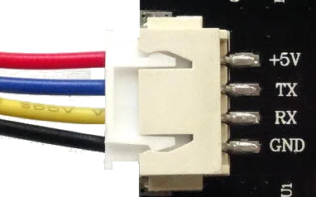

# System Setup and Program Loading

|  |
| --- |
| **A screenshot of a cell phone  Description automatically generatedStep 1 – Get a copy of the Teensy program file**  Download **4Rose.hex** to your computer. |
|  |
| **Step 2 – Get a copy of the Nextion configuration file**  Download **RoseEngine_14.tft**, and put it in the root folder of a microSD card.  **Notes:**   1. You can only have one file on this card which is a .TFT file. The upgrade will not work if there is a 2d one. 2. You need to check for hidden files on the microSD card. I found that hard to do on macOS (which created a hidden TFT file) and had to do this on a Raspberry Pi. |
|  |
| **Step 3 – Get a copy of the 4Axes.ini settings file**  Download **4Axes.ini**, and put it in the root of a second microSD card. |
|  |
| **Step 4 - Upgrade the Teensy**  **Step 4a**  Connect the computer to the Teensy.   * The cable end connected to the Teensy uses a MicroUSB connector. * The Teensy’s jack is noted in the picture to the right.   **Notes:**  Be sure you have a good MicroUSB cable. Some are only used for charging a device (and they are usually longer). These will often not work. |
|  |
| **Step 4b**  On the Computer, start the **Teensy Loader**. The icon looks like the one to the right.  **Note:**  If you don’t have the **Teensy Loader**, you can get it from <https://www.pjrc.com/teensy/loader.html>. |
|  |
| **A picture containing game  Description automatically generatedStep 4c**  Be sure the system shows that the Teensy is connected. This is evident when the Auto button is illuminated green. As noted in step 4a above, if your USB cable is bad, this won’t light.  The default for the CPU selected won’t handle the whole 4Rose.hex file, so if you try to open it, you will get the message as shown here. |
|  |
| **Step 4d**  Press the button on the Teensy to load the get the Teensy loader. This will enable the Teensy loader to recognize which CPU you are using and allow the larger program to be loaded. |
|  |
| **A picture containing game  Description automatically generatedStep 4e**  On the Computer, using the **Teensy Loader**, open **4Rose.hex**.  Once this is loaded, the bottom message will change to reflect the file size (this picture was not updated). |
|  |
| **Step 4f**  Press the button on the Teensy to load the program file.  Disconnect the computer from the Teensy, and then reboot the Teensy. |
|  |
| **Step 5 – Upgrade the Nextion**  Secure the microSD card which has the Nextion configuration file (from step 2).  Put this microSD card into the Nextion’s microSD card slot.  Reboot the Teensy again.  If this works as expected, it will read  Check Data … 100%  Updated Successed!  (guess that is a bad translation from Chinese).  After that message appear, remove the microSD card from the Nextion, and reboot the Teensy again. |
|  |
| **Step 6 - Load the .ini file**  Secure the microSD card which has the **4Axes.ini** settings file (from step 3).  Put this microSD card into the Teensy’s microSD card slot.  A close up of a device  Description automatically generated  Start the system and click the **Load ini** button on the Nextion screen.  The Load ini button will turn green, and then it will take off.  Once completed, a message will appear saying  Done – Restart may be needed.  Reboot the system one last time. |
| **Step 7 – Verify the Settings**  It's a good practice to verify all of the settings once you've completed the steps.     1. Touch the Config button on each page and verify the Teensy column is populated with the same numbers as the Nextion column.  Repeat for each axis on each page. 2. Next verify the Preferences are correct for the Spindle, Axes, Limits, and Returns. 3. Select the Main page, then the '...' (Preferences) page.  Select the More page. Touch EEPROM.  Repeat for each page and axis on the page.  This will show all of the settings for the selected page.   A copy of the settings file (4Axes.ini) is on the following pages. |

# Finishing It Up

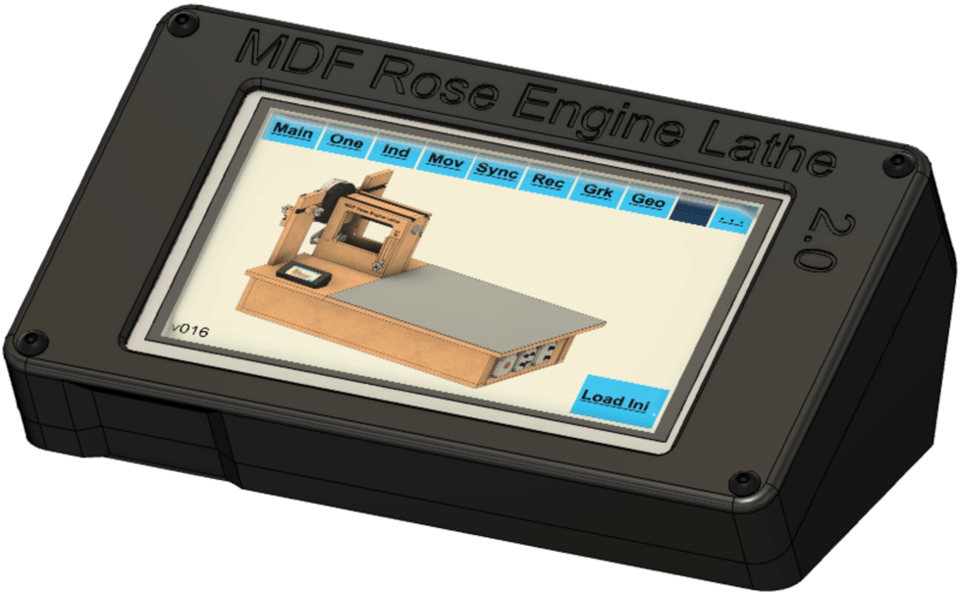Before screwing the bezel to the base, check to be sure everything works. To do that, you will need to use the instructions in the next section to load the programs into all the pieces.

If it works, screw the two pieces together using the four #4-40, ¾” long screws.

When finished and powered on, it will look like the picture to the right.

# 4Axes.ini Config File Settings

;====================================

[Setup]

;====================================

BoardType=4

Microsteps_Spindle=32

StepsPer360_Spindle=200

GearRatio_Spindle=9

Polarity_Spindle=1

;Z Axis

Microsteps_Z=32

StepsPer360_Z=200

DistancePer360_Z=.02

Polarity_Z=1

;X Axis

Microsteps_X=32

StepsPer360_X=200

DistancePer360_X=.02

Polarity_X=1

;B Axis

Microsteps_B=32

StepsPer360_B=200

GearRatio_B=150

Polarity_B=1

DistancePer360_B=1.02

RadialOrLineal=0

BRadius=5

;====================================

[Limits]

;====================================

;Limit Switches

Min_Z=34

Max_Z=35

Min_X=36

Max_X=37

Min_B=38

Max_B=39

;====================================

[Returns]

;====================================

;Return

MaxSpeed_Spindle=15011

Accel_Spindle=15012

MaxSpeed_Axis_Z=15013

Accel_Axis_Z=15014

MaxSpeed_Axis_X=15015

Accel_Axis_X=15016

MaxSpeed_Axis_B=15017

Accel_Axis_B=15018

;====================================

[Main]

;====================================

;Axis Ids:

;-----------------

;Z=0

;X=1

;B=2

;Spindle=3

;-----------------

AxisId=0

;Spindle

MaxSpeed_Spindle=15000

Accel_Spindle=15001

SpeedPercentage_Spindle=30

;Z Axis

MaxSpeed_Z=4001

Accel_Z=5002

SpeedPercentage_Z=53

;X Axis

MaxSpeed_X=4000

Accel_X=5005

SpeedPercentage_X=10

;B Axis

MaxSpeed_B=5007

Accel_B=5008

SpeedPercentage_B=59

;====================================

[One]

;====================================

AxisId=3

;Spindle

MaxSpeed_Spindle=25060

Accel_Spindle=20061

SpeedPercentage_Spindle=61

;Z Axis

MaxSpeed_Z=5062

Accel_Z=5063

SpeedPercentage_Z=64

;X Axis

MaxSpeed_X=5065

Accel_X=5066

SpeedPercentage_X=67

;B Axis

MaxSpeed_B=5068

Accel_B=5069

SpeedPercentage_B=70

;====================================

[Ind]

;====================================

IndexId=1

MaxSpeed_Spindle=5070

Accel_Spindle=5071

SpeedPercentage_Spindle=72

;-----------------

;Division:0 Degrees:2

;Fixed:0 File:1

;-----------------

;Index 1

DivisionsOrDegrees_1=2

FixedOrFile_1=0

Size_1=1.875

;Index 2

DivisionsOrDegrees_2=2

FixedOrFile_2=0

Size_2=24.375

;Index 3

DivisionsOrDegrees_3=2

FixedOrFile_3=0

Size_3=90

;====================================

[Mov]

;====================================

AxisId=0

;Z Axis

MaxSpeed_Z=5080

Accel_Z=5081

SpeedPercentage_Z=82

Distance_Z=3

;X Axis

MaxSpeed_X=5083

Accel_X=5084

SpeedPercentage_X=85

Distance_X=5.75

;B Axis

MaxSpeed_B=5086

Accel_B=5087

SpeedPercentage_B=88

Distance_B=5.78

;====================================

[BE]

;====================================

AxisId=0

;Spindle

MaxSpeed_Spindle=5090

Accel_Spindle=5091

SpeedPercentage_Spindle=92

;Z Axis

MaxSpeed_Z=5093

Accel_Z=5094

SpeedPercentage_Z=95

;X Axis

MaxSpeed_X=5096

Accel_X=5097

SpeedPercentage_X=98

;B Axis

MaxSpeed_B=5099

Accel_B=5100

SpeedPercentage_B=50

;====================================

[Sync]

;====================================

AxisId=0

HelixType=0

Revolutions=.3

Distance=10

;Spindle

MaxSpeed_Spindle=5040

Accel_Spindle=5041

SpeedPercentage_Spindle=42

;Z Axis

MaxSpeed_Z=5043

Accel_Z=5044

SpeedPercentage_Z=45

;X Axis

MaxSpeed_X=5046

Accel_X=5047

SpeedPercentage_X=48

;B Axis

MaxSpeed_B=5048

Accel_B=5049

SpeedPercentage_B=49

;====================================

[Rec]

;====================================

AxisId=0

RadialOrAxial=0

;Spindle

MaxSpeed_Spindle=5030

Accel_Spindle=5031

SpeedPercentage_Spindle=32

;Z Axis

MaxSpeed_Z=5033

Accel_Z=5034

SpeedPercentage_Z=35

;X Axis

MaxSpeed_X=5036

Accel_X=5037

SpeedPercentage_X=38

;B Axis

MaxSpeed_B=5039

Accel_B=5040

SpeedPercentage_B=39

;Radial

Radial_Waves=5

Radial_Spindle_Amplitude=20

Radial_Axis_Distance=5

;Axial

Axial_Waves=4

Axial_Spindle_Degrees=25

Axial_Axis_Amplitude=7

;====================================

[Grk]

;====================================

AxisId=0

FileOrPattern=0

;Spindle

MaxSpeed_Spindle=5020

Accel_Spindle=5021

SpeedPercentage_Spindle=22

;Z Axis

MaxSpeed_Z=5023

Accel_Z=5024

SpeedPercentage_Z=25

;X Axis

MaxSpeed_X=5026

Accel_X=5027

SpeedPercentage_X=28

;B Axis

MaxSpeed_B=5028

Accel_B=5029

SpeedPercentage_B=29

;Pattern page

RadialOrAxial_Pattern=0

;4a: 2 4b: 3 3a: 6 3b: 7 2a: 4 2b: 5

PatternType=4

Pattern_PatternsPer360=8

Pattern_PatternCount=1

Pattern_SegmentLength=1

;File page

RadialOrAxial_File=0

File_PatternsPer360=7

File_PatternCount=1

File_SegmentLength=1

;Segments: 2 Actual: 3

File_SegmentsOrActual=2

;====================================

[Geo]

;====================================

AxisId=0

RadialOrAxial=0

Rose_n=7

Rose_d=5

;Spindle

MaxSpeed_Spindle=5010

Accel_Spindle=5011

SpeedPercentage_Spindle=12

;Z Axis

MaxSpeed_Z=5013

Accel_Z=5014

SpeedPercentage_Z=15

RadialAmplitude_Z=2

AxialAmplitude_Z=2.5

;X Axis

MaxSpeed_X=5016

Accel_X=5017

SpeedPercentage_X=18

RadialAmplitude_X=2

AxialAmplitude_X=2.5

;B Axis

MaxSpeed_B=5018

Accel_B=5019

SpeedPercentage_B=19

RadialAmplitude_B=3

AxialAmplitude_B=3.5

# Document Version History

|  |  |  |
| --- | --- | --- |
| Ver | Date | Comment |
| 1.0 | 01 Dec 20 | Initial document |
| 1.0.1 | 05 Dec 20 | Pg. 8 – Updated commentary about stepper motor needed.  Pg. 8-9 – Added information about stepper motor mount, pulleys, and belt.  Pg. 19 – Updated drawing dimensions. |
| 1.0.2 | 07 Dec 20 | Pg. 7 – Updated p/n for item #204; also updated p/n & qty for item 102.  Pg. 28 – Added note on soldering on 3.5mm jacks first. |

To the extent that material may appear to be infringed, we assert that such alleged infringement is permissible under fair use principles in U.S. copyright laws. If you believe material has been used in an unauthorized manner, please contact me at [ColvinTools@Gmail.com](mailto:ColvinTools@Gmail.com).

The layout of the Printed Circuit Board (PCB) is copyright Ed French and is used with his permission.

Permission is not granted to manufacture these for sale.